VITyarthi - Build Your Own Project
PROJECT REPORT
MindTrack-CLI
An Offline Command-Line Application for Journaling, Mood Tracking and Stress Self-Assessment
Submitted by
Aman Kumar
Registration No.: 26BCE10427
Course: CSE CORE
Faculty / Mentor: Ashfaq Ahmad Najar
GitHub repository: https://github.com/aman-kumar2027/Mind_track
September 2026
Technologies: Python 3.13 | CSV and plain-text storage | Standard library only

Contents
1. Cover Page
2. Introduction
3. Problem Statement
4. Functional Requirements
5. Non-functional Requirements
6. System Architecture
7. Design Diagrams (Use Case, Workflow, Sequence, Class/Component, ER)
8. Design Decisions & Rationale
9. Implementation Details
10. Screenshots / Results
11. Testing Approach
12. Challenges Faced
13. Learnings & Key Takeaways
14. Future Enhancements
15. References

2. Introduction
Public awareness of mental health has grown in recent years, but turning awareness into a daily habit is harder. Reflecting on one's feelings regularly, writing thoughts down and noticing patterns in mood are simple practices, yet many people, especially students balancing academic pressure with personal life, do not maintain them. Existing digital tools are often feature-heavy, require accounts and internet access, or store personal content on remote servers.
MindTrack-CLI is a lightweight terminal application written in Python that removes these barriers. It lets a user write dated journal entries, log a daily mood, receive a positive affirmation and take a five-question stress check, all from a numbered menu. Everything is stored in two local files, journal.txt and mood.csv, and the program needs nothing beyond a standard Python installation.

Purpose of this report
This report documents the problem, requirements, design, implementation, testing and lessons learned for MindTrack-CLI, following the structure prescribed in Section 6 of the VITyarthi Build Your Own Project guidelines.
Note: MindTrack-CLI supports self-reflection only. The stress questionnaire is a simple, non-clinical check and must not be treated as a diagnosis or a substitute for professional help.

3. Problem Statement
Mental health awareness has increased, but many people still lack consistent habits of emotional reflection because of a lack of simple tools, privacy concerns or over-complicated apps. This project delivers an offline, beginner-friendly command-line application that encourages self-reflection through journaling, mood logs and guided assessments while safeguarding data locally.

Scope
To provide users with an easy-access and convenient space for self-reflection. The scope covers journaling, mood logging, affirmations and a short stress questionnaire in a single-user, offline terminal program. Clinical diagnosis, cloud synchronisation and multi-user accounts are outside the scope.

Target users
- Students who are stressed by academic and personal-life problems.
- People with privacy concerns who want to store their thoughts locally.

Objectives
- Offer a simple, user-friendly menu interface that works fully offline.
- Store journal entries and mood logs locally, with automatic date stamps.
- Provide a quick stress self-check with a clear Low / Moderate / High result.
- Encourage positivity through on-demand affirmations.
- Demonstrate sound use of Python functions, file handling, the csv module and exception handling.

4. Functional Requirements
MindTrack-CLI has four major functional modules (Journal, Mood Tracker, Affirmation, Stress Assessment) coordinated by a Main Menu, with a clear input/output structure for each requirement.
ID | Module | Requirement | Input | Output
FR1 | Main Menu | Show a numbered menu (options 1-7) in a loop until the user chooses Exit; reject any other input with an error message. | Menu choice (text) | Menu, or 'Invalid option. Try again.'
FR2 | Journal | Accept one journal entry and append it to journal.txt as a line stamped with today's date. The file is created if it does not exist. | Free text entry | 'Entry saved' confirmation; new line in journal.txt
FR3 | Journal | Display all saved journal entries; show a friendly message when no journal file exists yet. | None | All entries, or 'No entries found yet.'
FR4 | Mood Tracker | Ask how the user feels (happy / sad / anxious / neutral / angry), convert the answer to lower case and append [date, mood] to mood.csv. | Mood word | 'Mood saved' confirmation; new row in mood.csv
FR5 | Mood Tracker | Display every logged mood as 'date → mood'; show a friendly message when no mood file exists yet. | None | Mood log, or 'No mood entries found.'
FR6 | Affirmation | Show one randomly chosen positive affirmation from a built-in list of five. | None | One affirmation
FR7 | Stress Assessment | Ask five questions on a 1-5 scale, add the answers (range 5-25) and classify: up to 10 Low, 11-18 Moderate, above 18 High, with a short advice message. | Five integers (1-5) | Stress level and advice
FR8 | Storage | Persist all data in local plain-text (.txt) and CSV files so that it is available in later sessions. | n/a | journal.txt, mood.csv
FR9 | Main Menu | Exit cleanly with a goodbye message when option 7 is chosen. | Option 7 | Goodbye message; program ends

5. Non-functional Requirements
The table lists eight non-functional requirements and the current status of each.
ID | Category | Requirement | How it is addressed in MindTrack-CLI | Status
NFR1 | Usability | A first-time user must be able to use every feature without instructions beyond the on-screen prompts. | Numbered menu, plain-language prompts, confirmation messages (✔ Entry saved!), emoji-based result cues. | Met
NFR2 | Privacy & Security | User data must never leave the user's device. | No network access and no third-party libraries; data is written only to local files. Files are plain text (not encrypted), so protection relies on the user's own device security. | Met
NFR3 | Portability | Run on common operating systems with no installation of extra packages. | Uses only the Python standard library (csv, datetime, random). Developed for Python 3.13; verified during documentation testing on Python 3.12 / Linux. | Met
NFR4 | Performance & Resource Efficiency | Respond instantly and use negligible memory and disk. | Appending a record is a constant-time file write; viewing reads the file once. Data volume for a personal diary is tiny. | Met
NFR5 | Reliability & Error Handling | Handle missing files and invalid menu choices without crashing; never lose earlier data. | FileNotFoundError is caught by the view functions; invalid menu options are rejected; files are opened in append mode so earlier entries are preserved. Non-numeric quiz answers and malformed CSV rows are not yet handled (see Testing). | Partially met
NFR6 | Maintainability | Code should be easy to read and extend. | One function per feature, file paths held in constants, section comments, consistent naming. The code currently lives in a single file (mindtrack.py). | Partially met
NFR7 | Scalability | Remain usable as the number of entries grows over months. | Text/CSV files are adequate for thousands of personal entries. A database would be required for very large histories or search-heavy features. | Limited
NFR8 | Logging / Monitoring | Record application errors for diagnosis. | Not implemented in the current version; listed under future enhancements. | Not met

6. System Architecture
The application uses a four-layer design: a terminal-based presentation layer, an application layer of four feature modules, Python standard-library helpers, and a local storage layer of two files.
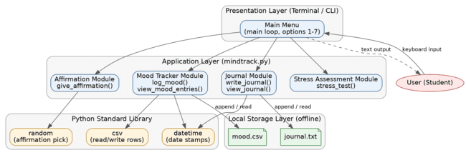
Figure 6.1: System architecture of MindTrack-CLI
Layer | Components | Responsibility
Presentation | Main menu loop (main()) | Displays the menu, reads the choice with input(), dispatches to a module, prints results.
Application | write_journal, view_journal, log_mood, view_mood_entries, give_affirmation, stress_test | Implements the feature logic: prompts, validation of the menu choice, scoring and classification.
Standard library | datetime, random, csv | Date stamps, random affirmation selection, CSV reading and writing.
Storage | journal.txt, mood.csv | Durable local storage; opened in append mode for writes, read mode for views.

7. Design Diagrams

7.1 Use Case Diagram
One actor (the User) interacts with seven use cases. Journal writing and mood logging include saving data locally; the questionnaire includes displaying the stress level.
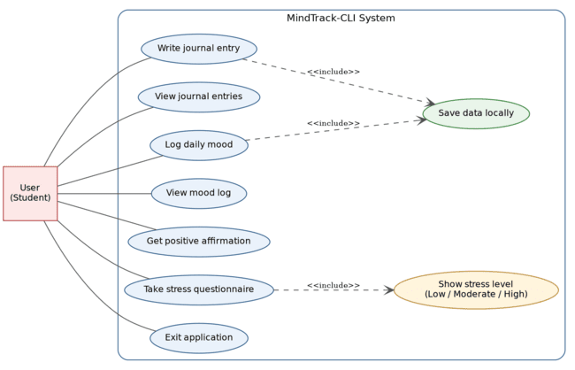
Figure 7.1: Use case diagram
ID | Use case | Main flow | Post-condition
UC1 | Write journal entry | User selects 1 → system prompts for text → user types entry → system stamps today's date and appends it to journal.txt → system confirms. | Entry stored in journal.txt
UC2 | View journal entries | User selects 2 → system reads journal.txt and prints all lines (or reports that no entries exist). | Entries displayed
UC3 | Log daily mood | User selects 3 → system prompts for mood → user types a mood word → system lower-cases it and appends [date, mood] to mood.csv → system confirms. | Row stored in mood.csv
UC4 | View mood log | User selects 4 → system reads mood.csv and prints each row as 'date → mood' (or reports that none exist). | Mood history displayed
UC5 | Get positive affirmation | User selects 5 → system picks a random affirmation and prints it. | Affirmation displayed
UC6 | Take stress questionnaire | User selects 6 → system asks five questions (1-5) → user answers each → system totals the score and prints Low / Moderate / High with advice. | Stress level displayed (not stored)
UC7 | Exit application | User selects 7 → system prints goodbye and ends the loop. | Program terminated

7.2 Workflow Diagram
The program loops: show menu, read choice, execute the action, and return to the menu until Exit is chosen.
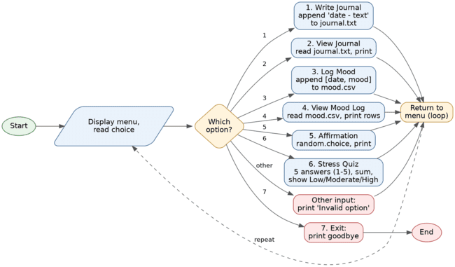
Figure 7.2: Workflow diagram

7.3 Sequence Diagrams
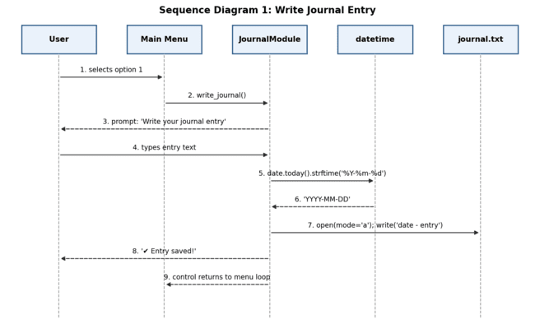
Figure 7.3: Sequence diagram - Write journal entry
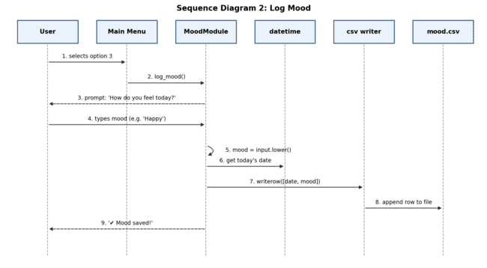
Figure 7.4: Sequence diagram - Log mood
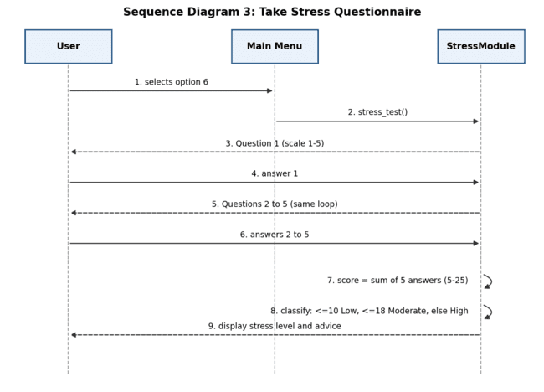
Figure 7.5: Sequence diagram - Take stress questionnaire

7.4 Class / Component Diagram
Because the program is procedural, the diagram uses components (groups of functions) and their dependencies rather than classes.
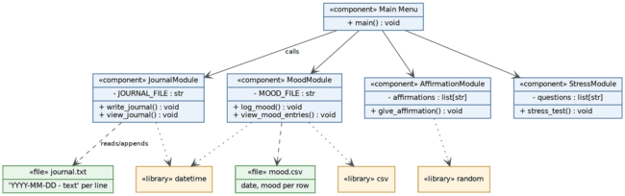
Figure 7.6: Component diagram

7.5 ER Diagram and Schema
Two entities are stored: journal entries and mood logs. A logical calendar-day entity explains that each date can have zero or more of each. Records are identified by line or row position.
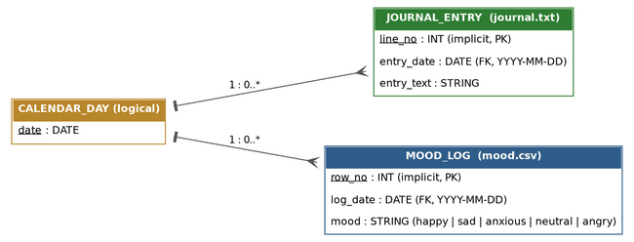
Figure 7.7: ER diagram

journal.txt schema (one line per entry: YYYY-MM-DD - text)
Field | Type | Format / rule | Example
date (prefix) | Text (date) | ISO format YYYY-MM-DD, taken from the system clock via datetime.date.today() | 2025-11-23
separator | Text | Literal ' - ' (space, hyphen, space) | -
entry | Text | Single-line free text from input(); no length limit | feeling happy today

mood.csv schema (one row per log: date,mood; no header)
Field | Type | Format / rule | Example
date (column 1) | Text (date) | ISO format YYYY-MM-DD from the system clock | 2025-11-23
mood (column 2) | Text | Lower-case word. Prompt suggests happy / sad / anxious / neutral / angry; the value is not restricted in code. | happy

8. Design Decisions & Rationale
Decision | Alternatives considered | Rationale
Command-line interface | Desktop GUI, web app | Fastest to learn and run, no dependencies, works on any machine with Python, and matches the 'simple and accessible' goal. Trade-off: less visual appeal.
Local .txt and .csv files | SQLite, JSON, cloud database | Human-readable, zero setup, easy to back up, and keeps data private on the device. The csv module gives reliable row handling for moods. Trade-off: no querying or encryption.
Python standard library only | Third-party packages (e.g. colour or CLI libraries) | Meets the 'no installation' promise, reduces security risk and keeps the project portable.
Append-mode writes | Rewrite whole file on each save | Previous entries can never be overwritten by a new save, and each save is one small write.
ISO date format (YYYY-MM-DD) | Locale-specific formats | Unambiguous, sorts correctly as text and is easy to parse later for statistics.
Lower-casing the mood | Store text exactly as typed | Makes 'Happy', 'HAPPY' and 'happy' identical, which is needed for counting moods in future.
Five-question, 1-5 scored quiz with thresholds 10 and 18 | Long clinical questionnaires | Short enough to finish in under a minute. Score range 5-25 splits into Low (5-10), Moderate (11-18) and High (19-25). It is a self-reflection prompt, not a validated clinical scale.
Result of the quiz is not stored | Save every score with a date | Keeps sensitive information off disk and keeps the storage design minimal; history tracking is listed as a future enhancement.
One function per feature, single source file | Package of several modules | Easier for a beginner to read and demonstrate. Trade-off: less separation of concerns; a multi-module package is planned (Section 14).

9. Implementation Details

9.1 Environment and project files
File | Purpose
mindtrack.py | Complete application: constants, feature functions and the main menu loop.
journal.txt | Data file created on first journal entry (one dated line per entry).
mood.csv | Data file created on first mood log (one row per log).
readme.md | Title, overview, features, technologies, install/run steps and test instructions.
statement.md | Problem statement, scope, target users and high-level features.

Language: Python 3.13 (also verified on Python 3.12). Libraries: csv, datetime and random from the standard library. Run: python mindtrack.py from the project folder.

9.2 Functions
Function | What it does | Key details
main() | Runs the menu inside while True, reads the choice and calls the matching function. | Choice 7 breaks the loop; any unknown value prints 'Invalid option. Try again.'
write_journal() | Prompts for text and appends it to journal.txt. | Date from datetime.date.today().strftime('%Y-%m-%d'); file opened with mode 'a'.
view_journal() | Prints the full contents of journal.txt. | FileNotFoundError is caught and a friendly message is shown.
log_mood() | Prompts for a mood word, converts it to lower case and appends [date, mood] to mood.csv. | Uses csv.writer with newline=''.
view_mood_entries() | Reads mood.csv with csv.reader and prints each row as 'date → mood'. | FileNotFoundError is caught and a friendly message is shown.
give_affirmation() | Prints one item chosen by random.choice from a list of five affirmations. | The list is a module-level constant.
stress_test() | Asks five questions (1-5), sums the answers and classifies the total. | Total 5-10 Low, 11-18 Moderate, 19-25 High; each level has an advice message.

9.3 Selected code
Writing a journal entry (append mode preserves earlier entries):
def write_journal():
entry = input("\nWrite your journal entry:\n> ")
date = datetime.date.today().strftime("%Y-%m-%d")
with open(JOURNAL_FILE, "a") as file:
file.write(f"{date} - {entry}\n")
print("\n✔ Entry saved!\n")

Logging a mood (csv module, normalised to lower case):
def log_mood():
mood = input("\nHow do you feel today? (happy/sad/anxious/neutral/angry): ").lower()
date = datetime.date.today().strftime("%Y-%m-%d")
with open(MOOD_FILE, "a", newline="") as file:
csv.writer(file).writerow([date, mood])

Stress classification (rule-based thresholds; the emoji used in the program output are omitted here):
if score <= 10:
print("Low Stress - You're doing great! Keep maintaining balance.")
elif score <= 18:
print("Moderate Stress - Take breaks & practice self-care.")
else:
print("High Stress - Consider talking to someone or seeking support.")

9.4 Workflow of use
- Start the program; the menu is displayed.
- Choose an option (1-7) and follow the prompts.
- After each action the menu appears again.
- Choose 7 to exit; data remains in the local files for the next session.

10. Screenshots / Results
The figures below show terminal output produced by running mindtrack.py; text typed by the user is shown in green. The emoji in the program output are drawn as simple symbols in these captures.
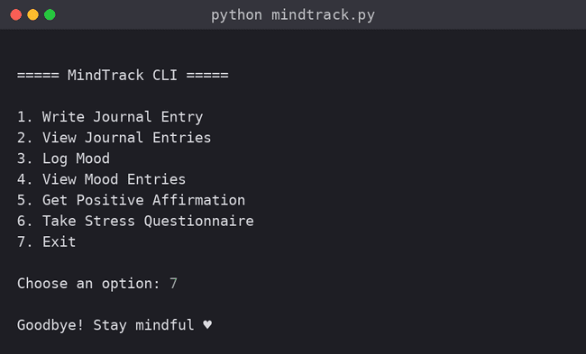
Figure 10.1: Main menu and exit
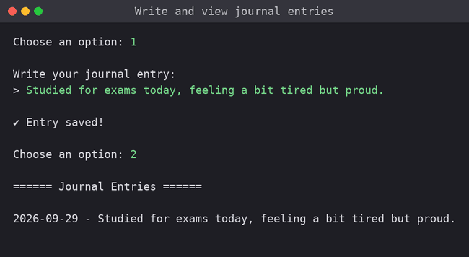
Figure 10.2: Writing and viewing a journal entry
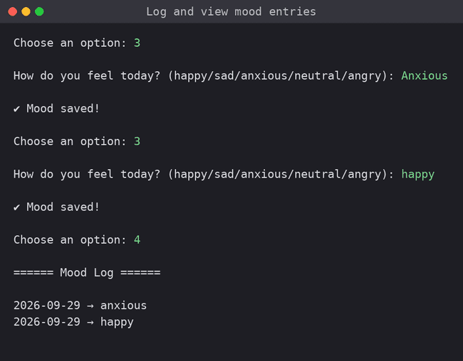
Figure 10.3: Logging and viewing moods
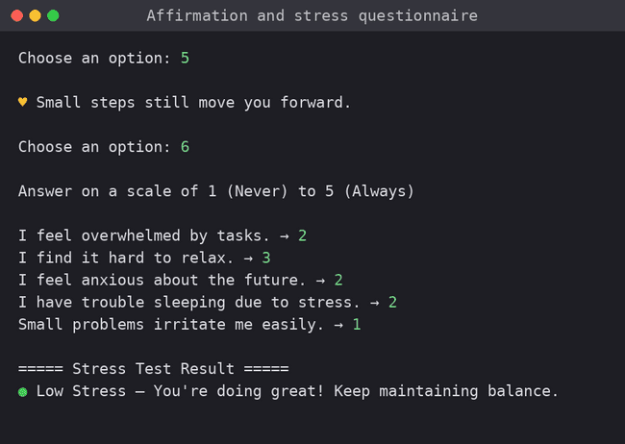
Figure 10.4: Affirmation and stress questionnaire (score 10 = Low Stress)
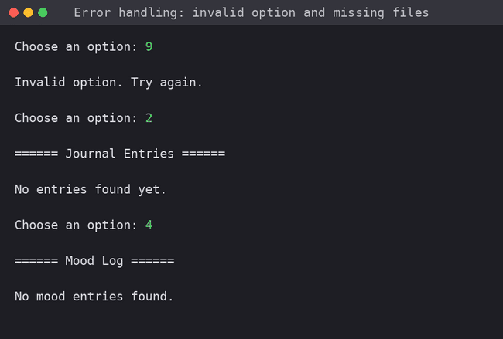
Figure 10.5: Invalid option and missing-file messages

Sample stored data
journal.txt: 2025-11-23 - feeling happy today
mood.csv: 2025-11-23,happy

11. Testing Approach
Testing was manual, black-box and scenario-based. Each menu option was exercised with normal input, then with boundary and invalid input. The stress classification was tested at the boundaries of each band (totals of 5, 10, 15, 19 and 25). Tests used a clean folder so that earlier data could not influence results.
ID | Test case | Steps / input | Expected result | Actual result
T1 | Write journal entry | Menu 1; type 'Studied for exams today, feeling a bit tired but proud.' | Line saved in journal.txt with today's date; 'Entry saved' shown | Pass
T2 | View journal entries | Menu 2 after T1 | Saved entry displayed | Pass
T3 | Log mood | Menu 3; type 'Anxious' | Row [date, anxious] appended to mood.csv | Pass
T4 | Mood normalisation | Menu 3; type 'HAPPY' | Stored as 'happy' (lower case) | Pass
T5 | View mood log | Menu 4 after T3/T4 | Each row shown as 'date → mood' | Pass
T6 | Affirmation | Menu 5 | One of the five stored affirmations displayed | Pass
T7 | Stress boundaries | Quiz totals 5, 10, 15, 19, 25 | 5 and 10 → Low; 15 → Moderate; 19 and 25 → High | Pass
T8 | Invalid menu option | Enter 9 at the menu | 'Invalid option. Try again.' and menu shown again | Pass
T9 | Missing data files | Menu 2 and 4 with no journal.txt / mood.csv | 'No entries found yet.' / 'No mood entries found.' | Pass
T10 | Exit | Menu 7 | Goodbye message; program ends | Pass
T11 | Non-numeric quiz answer | Menu 6; answer 'abc' | Prompt again or show an error message | Fail: program stops with ValueError
T12 | Malformed CSV row | Blank line at the start of mood.csv; Menu 4 | Blank row skipped | Fail: IndexError stops the program
T13 | Unlisted mood value | Menu 3; type 'excited' | Ask again or reject values outside the list | Observation: value accepted and stored

Summary of results
- 10 of 13 test cases passed: all core features, the stress boundaries, invalid menu handling and missing-file handling behave as specified.
- Two defects were found: a non-numeric answer in the questionnaire (T11) and a blank or malformed row in mood.csv (T12) each stop the program with an unhandled exception.
- One observation (T13): mood values outside the suggested list are accepted, which could make later mood statistics inconsistent.
These findings are recorded as known limitations and drive the input-validation items in Section 14. Automated tests (unittest or pytest) are also planned once the code is split into modules.

12. Challenges Faced
The following challenges and limitations came up while designing, building and testing the project.
Challenge | How it was handled / current status
Keeping the tool simple while still useful | Limited the feature set to four modules and a numbered menu; avoided accounts, settings and external packages.
Protecting privacy without encryption | Chose fully local files and no network access. Encryption was left as a future step because it would add complexity for beginners.
Choosing the storage format | Compared databases and JSON with plain files; used .txt for free text and .csv for structured mood rows.
Correct CSV writing | Opened mood.csv with newline='' and used csv.writer so rows are written cleanly on all platforms.
Designing a fair stress scoring scheme | Used five questions on a 1-5 scale and three bands. It is deliberately labelled as a self-check, not a clinical scale.
Invalid user input | Menu input and missing files are handled; testing showed that quiz answers and malformed CSV rows still need validation (open defects T11, T12).
Structure required by the guidelines | The current implementation is one source file; splitting it into several modules with tests is the main planned improvement.
Text encoding across systems | Files are opened with the platform default encoding. Non-English characters could behave differently on some Windows setups; explicit UTF-8 is planned.

13. Learnings & Key Takeaways
- Reading and writing files in Python, including the difference between read ('r') and append ('a') modes.
- Using the csv module for structured data and the datetime and random modules for dates and randomness.
- Using functions to keep each feature separate, and a while loop with if/elif branching to build a menu-driven program.
- Handling exceptions such as FileNotFoundError gracefully, and realising through testing where ValueError and IndexError can still occur.
- Designing for privacy and simplicity: constraints (offline, no dependencies) shaped good design choices.
- Writing requirements and drawing UML, workflow and ER diagrams before and after coding makes the design easier to explain and review.
- Testing with invalid and boundary input finds problems that normal use never reveals.

14. Future Enhancements
Enhancement | Benefit
Input validation loops (numeric 1-5 answers, mood chosen from the list, skip blank CSV rows) | Removes defects T11-T13 and makes the program robust.
Refactor into a package (for example main.py, journal.py, mood.py, affirmations.py, stress.py, storage.py) with a tests/ folder | Better modularity and maintainability; enables unit tests.
Automated unit tests with unittest or pytest | Repeatable verification of scoring, file handling and validation.
Explicit UTF-8 encoding when opening files | Consistent behaviour for all characters on all systems.
Mood summary and trends (counts per mood, weekly view, streaks) | Turns raw logs into insight and encourages the habit.
Search, edit and delete journal entries (full CRUD) | More control over stored data.
Save questionnaire results with dates | Shows stress changes over time.
Optional password protection or encryption of data files | Stronger privacy on shared computers.
Logging of errors to a local log file | Easier diagnosis and monitoring.
Export to a text or PDF summary; optional reminders; a simple GUI | Wider usability.

15. References
- Python Software Foundation. The Python Standard Library: csv - CSV File Reading and Writing. https://docs.python.org/3/library/csv.html
- Python Software Foundation. The Python Standard Library: datetime - Basic date and time types. https://docs.python.org/3/library/datetime.html
- Python Software Foundation. The Python Standard Library: random - Generate pseudo-random numbers. https://docs.python.org/3/library/random.html
- Python Software Foundation. Built-in Functions: open() and input(). https://docs.python.org/3/library/functions.html
- Van Rossum, G., Warsaw, B., Coghlan, N. PEP 8 - Style Guide for Python Code. https://peps.python.org/pep-0008/
- Object Management Group. Unified Modeling Language (UML) Specification. https://www.omg.org/spec/UML
- Graphviz Project. Graphviz - Graph Visualization Software (used to draw diagrams). https://graphviz.org
- VITyarthi. Build Your Own Project: General Project Instructions & Submission Guidelines.

